**Team Digimon**

Progress Report

Completed: October 5, 2018

**Draft Description**

**ALU Description:**

For our team project we will be creating an Arithmetic Logic Unit (ALU). An ALU is used to perform logic and arithmetic operations. It is also the foundation for the CPU and simple microprocessors. The two basic components of the ALU is the Arithmetic Unit and the Logic Unit. The ALU loads the data from the input registers which then decides which operation to perform with the help of the control unit. Finally, it executes and stores the result into the output register.

**ALU Design:**

Our ALU will be able to handle any 8 bit integer. It will able to be able to perform typical math functions such as add, subtract, and shift left/right. Our ALU will also be able to perform typical logical functions such as AND, OR, XOR with two inputs and NOT with one input. In addition to math and logical functions, our ALU will also be able to handle overflow errors and carry-over errors.

Our ALU will be inputs from two separate wires going in the ALU. There will be another wire going into the ALU from the control unit to determine what instruction to operate to those input. There will be another two wires going out of our ALU one will be the output of the ALU and the other one should be able to catch errors like carry-over and overflow.

**Draft Member Tasks**

|  |  |
| --- | --- |
| ***Cohort Member*** | ***Tasks*** |
| Feba Jacob | 1. Research logic functions and carry-over 2. Implementing Logic operations 3. Circuit Diagrams 4. Accumulator |
| Marian Lusk | 1. Research logic functions and overflow 2. Implementing Logic Operations 3. Circuit Diagrams 4. Documentation |
| Danh Nguyen | 1. Research math functions and overflow 2. Implementing math operations 3. Circuit Diagrams 4. Accumulator |
| Zana Warren | 1. Research math functions and carry-over 2. Implementing math operations 3. Circuit Diagrams 4. Documentation |

**Software Discovery**

As a team, we have all agreed to code in Icarus Verilog. iVerilog was the cheapest and easiest for all of us to install. We used this software for various homework and is familiar with this language style. Thus, as a team we came to the consensus that it would be our best option to use this software.

Currently we are doing our drawings with pencil, paper and stencil as our main focus is mastering the Verilog code and understanding the basics of the circuits we are trying to create.

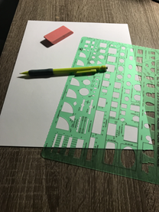

**Participation Census**

|  |  |
| --- | --- |
| **Name** | **Percentage** |
| Feba Jacob | 25% |
| Marian Lusk | 25% |
| Danh Nguyen | 25% |
| Zana Warren | 25% |

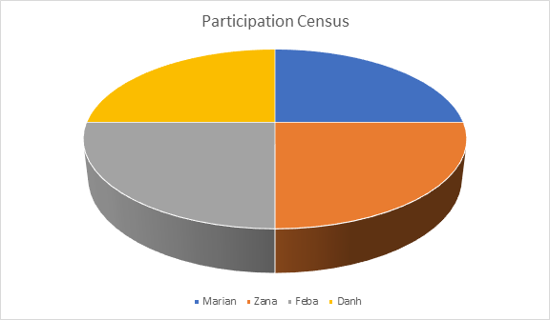

We divided our group in a way each of us contribute to 25% of the work. Also, as one task of a member overlap with another team member it is easier for us to help keep each member accountable for their assignment.